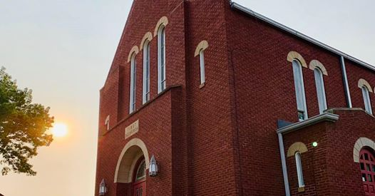

First United Methodist Church of Ellwood City
July 2021
Newsletter

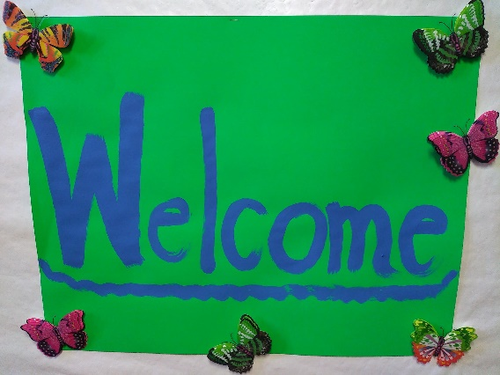

We welcome Pastor Jay Sterling. Pastor Jay will have office hours Mondays 9:30 am – 12:30 pm and Wednesdays 9:30 am – 12:00 pm. If you need to reach him outside of office hours, contact him at 724-988-9150 or pastorjay58@yahoo.com.

We look forward to this new charge and our future together!

“The steadfast love of the Lord never ceases; his mercies never come to an end; they are new every morning; great is your faithfulness.” Lamentations 3: 22-23

FROM THE PASTOR’S CLUTTERED DESK
“So then you are no longer strangers and aliens, but you are fellow citizens with the saints and members of the household of God…” --Ephesians 2:19 (ESV)

It is a joy to begin this ministry with you here at First UMC. I am not a stranger, having served at Wurtemburg these past three years and having worshiped with many of you on a few occasions, but I do feel it is a special privilege to have been appointed as your pastor for our journey ahead together and with our brothers and sisters at Wurtemburg.
A few background notes: I was born and raised in Oil City. I dropped out of the church shortly after I was confirmed, declared myself to be an atheist, and firmly resisted all attempts by my family and a number of friends to share their faith with me. Two weeks before I left for college at the University of Pennsylvania in Philadelphia, Jesus found me. You will be hearing more of that story over the course of our ministry together.
At Penn, I was deeply involved with InterVarsity Christian Fellowship, led a Bible study, and was chapter president my senior year. During my freshman year I received my call to the ministry and changed majors from Chemical Engineering to History (from practical to loved). As I approached graduation, I did not feel ready to go straight on to seminary so I applied to the US-2 mission intern program through our General Board of Global Ministries. I served for two years with Community Ministry of Montgomery County, Maryland and Fairhaven UMC in Gaithersburg—you will be hearing more about those experiences!
I attended Wesley Theological Seminary in Washington, DC and graduated with my M. Div. degree, summa cum laude, in May 1985. During my last year as a US-2 and my first two years of seminary, my relationship with Martha Grimm, a fellow alum from Penn who had been in one of the Bible studies I led there, grew from friendship into marriage in May 1984.
Martha and I have been privileged to serve in five congregational appointments over the past 36 years: Creekside (1985-1992); Eldersville (1992-2000); Clarks Mills (2000-2011); Conneaut Lake: Trinity (2011-2018); Wurtemburg/Koppel (2018-2021). During these years God has blessed us with three daughters: Sarah (husband Jacob and grandchildren Holden and Mira); Joanna; and Lydia (who will graduate from Duquesne in August and marry Adam in October).
Well, that’s a start in our getting acquainted. Just remember, you only have two of us to get to know and we have all of you—be patient as we learn your names and more about you! Oh, and one more thing, you may call me Jay—Jay is who I am, pastor is what I do—but if you feel more comfortable calling me Pastor Jay, I answer to that as well.

Shalom,
Jay (Pastor Jay)

Prayers for Our Members, Friends and Community

Our Father, who art in heaven, hallowed be thy name. Thy kingdom come, thy will be done on earth as it is in heaven. Give us this day our daily bread. And forgive us our trespasses, as we forgive those who trespass against us. And lead us not into temptation, but deliver us from evil. For thine is the kingdom, and the power, and the glory, forever. Amen.

Prayer Concerns

Our Nation
National and Local Elected Officials
Skyla, who recently received a bone marrow transplant
The Family of Teri Beeler
Mr. John Horvath & family, critical health concerns
Brenda and Rick Lance, health and family concerns
Jennifer Milne
Mike Anesin, cousin of Candy Aikins, health concerns
Bob Johnson, health concerns
Lloyd & Polly Cline
Bill & Marynelle Kness
Mr. John Yeager, health concerns
Eve Yeager, health concerns
Ruth Thomas health concerns
Our Shut-ins
Our Youth and Young Adults
Victims of gun violence
Students, Teachers and Staff at Ellwood, Riverside and Beaver Falls Schools
Families who are coping with day-to-day anxieties
Marriages and strained relationships
Those struggling with substance abuse, addiction and/or mental illness
All who are suffering from cancer and/or other illnesses
All who are suffering in silence
Those who lost employment because of COVID-19
Those struggling with acceptance
Those struggling with spiritual and social isolation due to the COVID-19 Pandemic
Healthcare & Essential Workers
Racial Injustice & Inequality
First United Methodist Church Ellwood City & Homewood United Methodist Church
The Western Pennsylvania Annual Conference and all its ministries
WPAC: Butler District Clergy and their ministries
Ellwood City Clergy and their ministries
Bishop Cynthia Moore-Koikoi, her family, The Cabinet, and the work of her hands

If you have any specific prayer requests contact the church office at secretary@fumcec.org or
724-758-6278

Independence Day
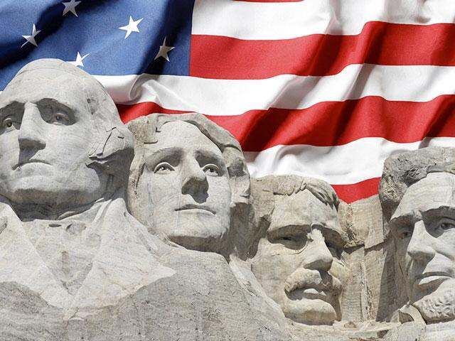

Almighty God, you rule all the peoples of the earth.
Inspire the minds of all women and men to whom you have committed
the responsibility of government and leadership
in the nations of the world.

Give to them the vision of truth and justice,
that by their counsel all nations and peoples may work together.
Give to the people of our country
zeal for justice and strength of forbearance,
that we may use our liberty in accordance with your gracious will.
Forgive our shortcomings as a nation;
purify our hearts to see and love the truth.
We pray all these things through Jesus Christ.
Amen.

(ANDY LANGFORD, U.S.A., 20TH CENT.)

What’s Happening at Church….

I would like to update our newsletter with a fresh look and new content but my creative talents have seem to run dry. If anyone is willing to help, please let me know. You do not have to come into the office. We can work together virtually. Email or call the office at secretary@fumcec.org or 724-758-6278 with any suggestions, comments, articles, etc. Thanks! ~ Jennifer

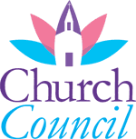

Tuesday, July 27, 2021
6:30 pm
Church Lounge

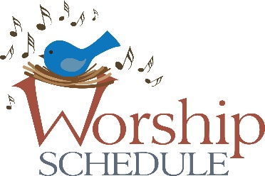

Sunday, July 4, 2021
11:00 am Sixth Sunday After Pentecost - Communion
Sermon “The Spirit of Liberality”
Mondays
6:30 pm - Boy Scouts

Wednesdays
VBS Mini Wednesdays
(See times and schedule below)
Sunday, July 11, 2021
11:00 am Seventh Sunday After Pentecost
Sermon “The Down Payment”

Sunday, July 18, 2021
11:00 am Eighth Sunday After Pentecost
Sermon TBA - Guest Preacher

Sunday, July 25, 2021
11:00 am Nineth Sunday After Pentecost
Sermon TBA – Guest Preacher

Visitation ~ If you would like a pastoral care visit or know someone who is homebound, in a nursing homes, or has experienced social or spiritual isolation, please contact Pastor Jay
at the church office or directly 724-988-9150

VBS Mini Wednesdays

Instead of a week-long VBS this year, we are hosting weekly
“VBS Mini Wednesdays” each Wednesday.

All children ages 3 and up of the church and community are welcome!

SCHEDULE OF ACTIVITIES

July 7, 2021 6:00 pm – 8:00 pm
Pam McDonald from Dance Expressions will be teaching a dance, a walking field trip to the fires station and an ice cream truck!
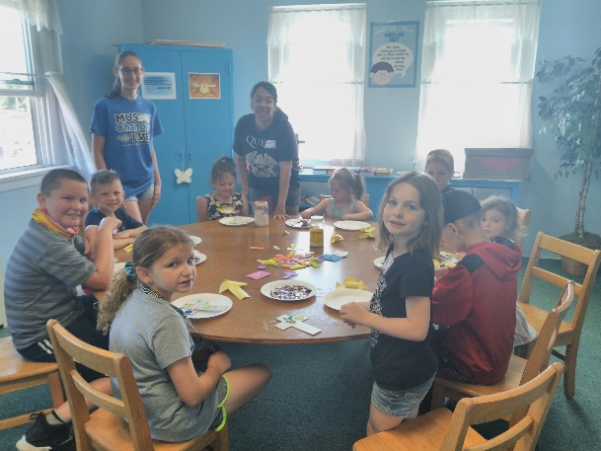
July 14, 2021 10:00 am – 12:00 pm
FUN!

July 21, 2021 6:00 pm – 8:00 pm
Our Boy Scouts will be leading us.

July 28, 2021 10:00 am – 12:00 pm
Pony Rides!

August 11, 2021 6:00 pm – 8:00 pm
Pet Blessing. Kids activities to begin at 6:00 pm. Families can arrive with pets at 7:30 pm for the blessing outside in the church yard. If you don’t have a pet, kids can bring a favorite stuffed animal : )

We are very happy to say that we have had a GREAT turnout for our VBS Mini Wednesday program so far this summer!!!

But....with all those little feet running through the halls and playing outside in the church yard, little tummies need snacks and tiny hands need things to keep them busy! If you are able, we are requesting donations of the below items or a monetary donation in any amount. You can contact Sandi Rectenwald at 724-944-4073, call the church office at 724-758-6278 or stop by during regular church office hours with any questions or to drop of your donations.

Some things we need:
*Snacks, prepackaged or something creative * A stapler with staples
*Fresh fruit such as grapes * Several rolls of scotch tape
* Napkins * Paper plates
* Glue sticks and bottles of school glue
*Drinks, small waters or Juice pouches such as Capri Sun
THANK YOU! ~ Christian Education Team at First UMC

2021 Youth and Young Adult Sundays
If you are interested in participating in any of these special Sundays, please contact Sandy Rectenwald
August 29, 2021
October 31, 2021

WPAUMC YOUTH INFORMATION
https://www.wpaumc.org/Youth

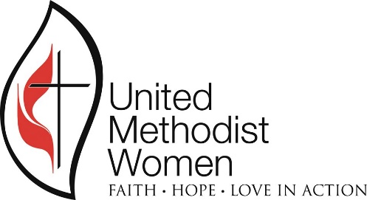

UMW Meetings will resume later 2021
on the third Saturday of each month.

We look forward to being together again soon!

The PURPOSE of United Methodist Women

The Purpose is adopted by the General Conference of The United Methodist Church as the official mission statement of United Methodist Women.
United Methodist Women shall be a community of women whose purpose is to know God and to experience freedom as whole persons through Jesus Christ; to develop a creative, supportive fellowship; and to expand concepts of mission through participation in the global ministries of the church.
https://www.wpaumc.org/UMWomen
https://www.unitedmethodistwomen.org/
GIVING BACK

Yellow Ribbon Girls
Starting in 2003 the Yellow Ribbon Girls and their ever faithful gang of volunteers create and ship monthly care packages to our troops deployed around the world. They ship between 70 - 100 care packages each month.

One Sunday a month, FUMC has a special collection for the Yellow Ribbon Girls. The money collected goes toward postage and other supplies the volunteers use to send care packages to our deployed troops. The many men and women who receive those care packages are so very thankful for our support. You can follow the YRG on Facebook for up-to-date information on recent endevors and also read messages from some of the reciepients of the care packages. www.yellowribbongirls.com

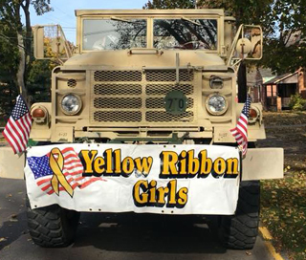

Holy Redeemer Social Services and Food Bank is in need non-perishable food donations. You may place your donations in the bin located in the Narthex or drop them off during church hours.

Yellow Ribbon Girls
Starting in 2003 the Yellow Ribbon Girls and their ever faithful gang of volunteers create and ship monthly care packages to our troops deployed around the world. They ship between 70 - 100 care packages each month.

One Sunday a month, FUMC has a special collection for the Yellow Ribbon Girls. The money collected goes toward postage and other supplies the volunteers use to send care packages to our deployed troops. The many men and women who receive those care packages are so very thankful for our support. You can follow the YRG on Facebook for up-to-date information on recent endevors and also read messages from some of the reciepients of the care packages. www.yellowribbongirls.com

Celebrating our Birthdays and Anniversaries

*Our records need updating….Please contact the church office via telephone or email with any birthday/anniversary updates.
ANNIVERSARIES

2 Charles and Nelly Schweinsberg III
13 William and Marynelle Kness
15 Bob and Lori Mohr
31 Al and Rusty Campman

BIRTHDAYS

3 Tyrel Hall
3 Chelsea Oliver
4 Blake Scala
4 Nancy Wilson
5 Ayla Burgess
5 Ed Kingston
5 Avery Schanno
5 Levi Smith
7 Melinda Weaver
8 Kathy Sapp
10 Ivy Frederick
11 Mark Aiken
11 Alivia Irwin
12 Lucy Wiley
14 Clarence Kingston
14 Adam Pratt
15 Renee Watterson
16 Lynda Cooper
16 Brooke Watterson
18 Bill Allen
19 Earl Cooper
19 Maggie Rupp
21 Doug Seaburn
22 Barbara Hall
22 Meredith Weingart
23 Lori Heaberlin
24 Elaine Wray
25 Noah Skelley
26 Joy Durlesser
26 Dorothy Wallace
28 Travis Hall
28 Wayne Hall III
28 Cathy Ketterer
28 Jean Kimpel
29 Gretta Cappello
31 Beth Dwyer
31 Eric Minett
31 Jerry Rectenwald

What’s Happening in the Community….

Ellwood City Fireworks
Friday, July 2 9:45 pm
The fireworks will be set off at Steifel Park.
Giant Eagle parking lot and Word Alive Church parking lot will be
open to view the fireworks

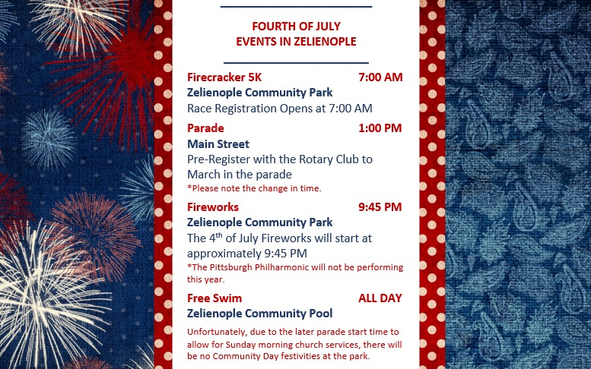

The Best of Broadway ~ July 9-11, 16-18 Red Barn Bandstand ~ July 30-August 1,
Augustt 6-8

Sincerely, Sinatra ~ August 20-22, 27-29
​​
General admission: $13
No reservations needed. All tickets are general admission for lawn seating.
Please report to the Box Office upon arrival.
Bring your own chairs.
You are welcome to bring picnics & beverages.
Gates open one hour before curtain.
CDC guidelines are applicable. Seating will be safely distanced.
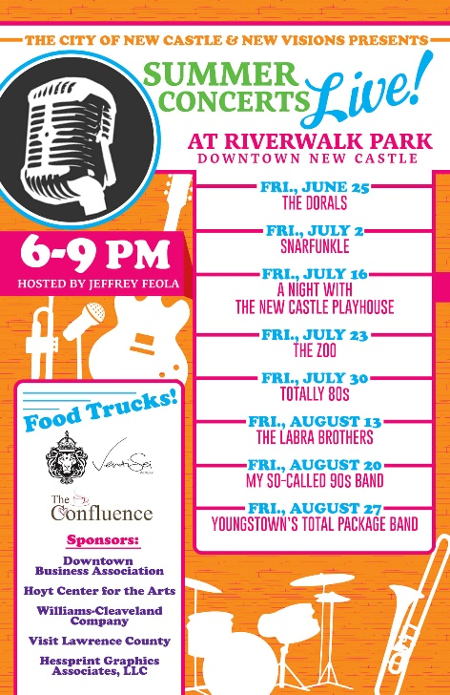

.

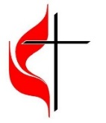
First United Methodist Church
416 Crescent Avenue
Ellwood City, PA 16117

First United Methodist Church
416 Crescent Ave., Ellwood City, PA 16117
Phone: 724-758-6278
Facebook.com/1stUMCEllwood
www.firstumcec.org

